# Slovenia: Nature, Food, & a Police Encounter

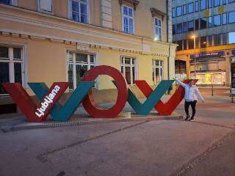

On Wednesday,  we headed out for a 3 hour drive to Slovenia. We chose Slovenia because some friends told us how beautiful it is, and since it's so close, we decided to give it a whirl. The country has a surprising amount of hills, mountains, craggy cliffs, and forests. We caught a glimpse of the Julian Alps to the north, and they are still covered in snow.

The Julian Alps are one of the mountain ranges in the Alps that are amicably shared between Slovenia and Italy. Two-thirds of it is located on the Slovenian side, in the

Triglav

National Park. The mountain range covers an area of ​​4,400 km. Its highest altitude is

2,864 meters

at the top of Mount Triglav.

FYI: 2864 meters is equal to 9396 feet in elevation.

A little more than halfway to Ljubliana (pronounced loob-lee-AWN-ah), we stopped in Trieste, Italy for lunch and a walkabout.  From the main highway, it is a steep descent into Trieste, a large city that also has a very large harbor. In the picture below, it might be hard to see, but the Adriatic Sea can be seen off in the distance.

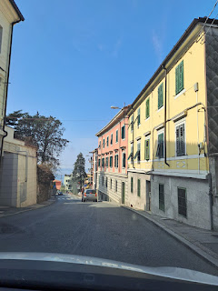

The road was very narrow on our descent into town, and it didn't feel like it should be meant for two-way traffic . . . but it was.

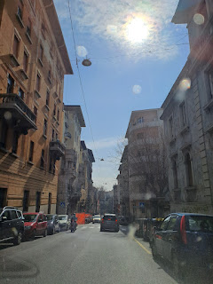

Below: A portion of what is called, "The Free Port of Trieste", the formal name for it being a large and industrious harbor. Trieste runs along the harbor, both north and south, and even into the hills to the north. The current population is approximately 205,000. It is heavily influenced by 3 cultures: Italian, Austrian, and Slovenian.

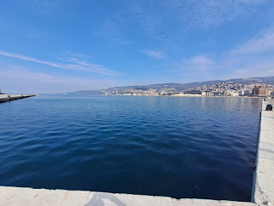

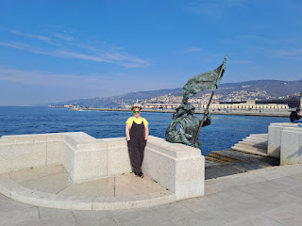

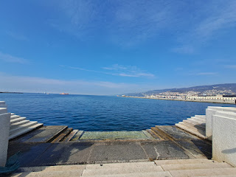

Video from where we stood at this spot: (28 seconds)

https://photos.app.goo.gl/Gta7c7v9PvzQtgcZ9

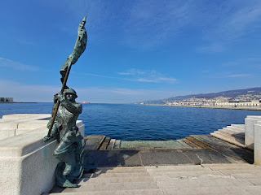

I loved the statues of these ladies sitting by the sea . . . reading and clipping something from the newspaper, while tending to their fingernails, and probably having a lovely gossip session together. :)

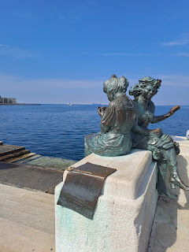

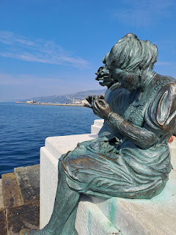

The Piazza across the street from this spot is called the Piazza Unita d'Italia. Apparently Mussolini gave a racist speech here in 1938 . . .

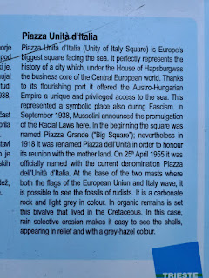

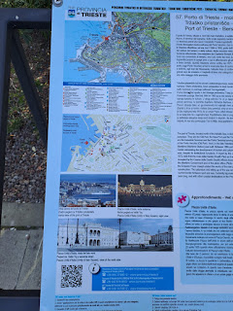

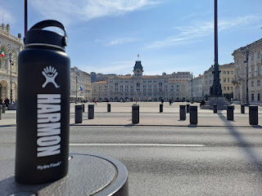

We sent this photo to our kids and asked them to play a game of "Find Dad". They never could find him. A hint of what color clothing he was wearing will be in some photos below, if you care to try.

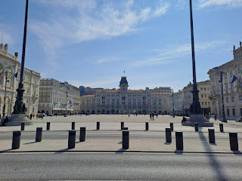

A closer photo of the fountain

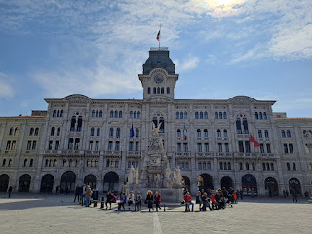

We both needed a bathroom, and learned in the Tourist Information Office that there is only ONE public toilet in the area. They call it a "water closet" and it's marked by a sign that says: WC. We had to go underground, similar to maybe going down to a subway station. And this was what I found.

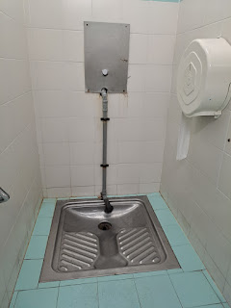

This was my only option. I looked in a couple of the other stalls to see if there was something better, but no, there wasn't. If you're a guy, no problem! But if you're a girl . . .

Yes, you put your feet on the ridged spots, then hold on to the ONE hand rail on the right, and lean back as far as you can so you don't make a mess of your clothes. Not what I would call fun.

This is called the "Grand Canal" of Trieste Port. It was adjacent to the water closets.

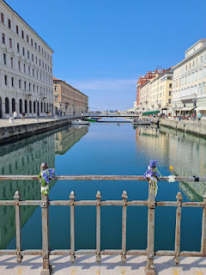

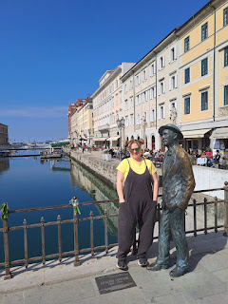

We followed the Grand Canal back out to the harbor and walked alongside it as we headed to lunch.

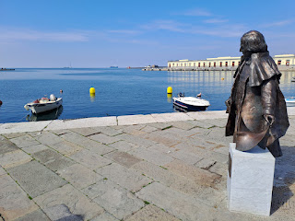

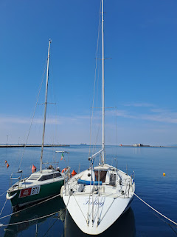

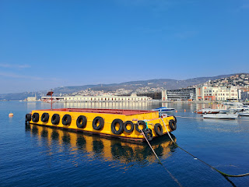

All the scooters reminded me of Florence, ha ha.

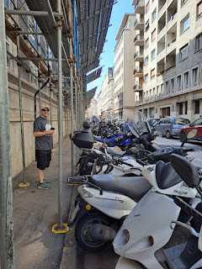

We found this cute cafe called "Mimi & Cocotte" and we had a lovely lunch there.

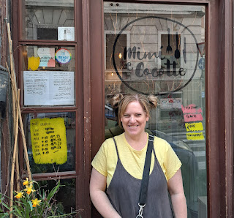

The waitress spoke excellent English and she explained the entire menu to us.

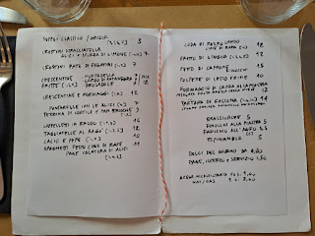

We chose the Crostini Stracciatella - a crusty bread with a creamy slathering, topped with fresh sardines; Topinambur, which is a version of Jerusalem Artichokes; and the Formaggio di Capra al la Piastra - arugula salad with a goat cheese patty on top of a slice of crusty bread. The salad had walnuts, cashews, seeds, blueberries, raspberries, and pears, along with a drizzle of honey. It was delicious!

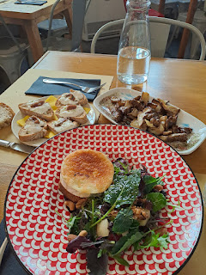

Partway through our lunch, a lady that worked in the cafe came and collected all of the flower vases off the tables, then refilled all of them with fresh flowers and brought them back out.

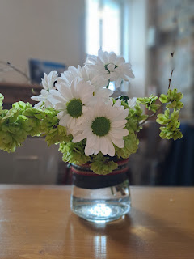

As we exited the cafe, I noticed this cheerful little hyacinth and daffodil just outside their door. :) I still am in shock to see all the flowers blooming over here!!

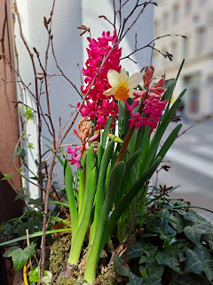

After lunch, we went back to our car and began driving toward the border crossing of Slovenia. We were really close during our pitstop in Trieste. Nobody stopped us at the border, and nobody asked to see our passports either. Cool.

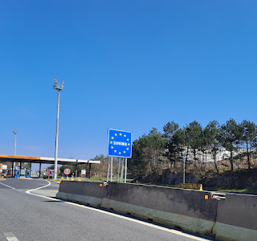

The wording on the street signs was sure different . . .

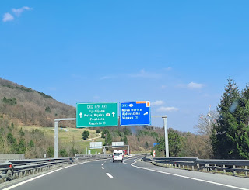

**Note: I got a lot of the ideas for our adventures in Slovenia from this blog:

https://www.earthtrekkers.com/best-things-to-do-in-slovenia/

Soon, we exited off the freeway and found a nice country road to drive on. Our destination was Predjama Castle, which is a little off the beaten path, but still on our way to the AirBnB in Ljubliana.

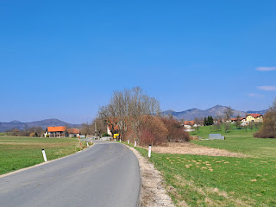

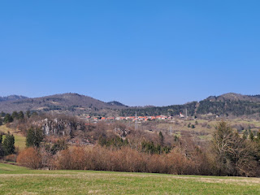

Predjama Castle parking lot . . . (aka Prediamski Grad)

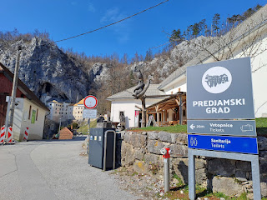

Always use the potty when there IS one . . . and thankfully this was a normal toilet this time.

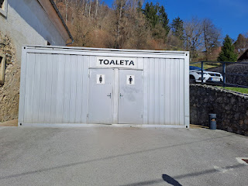

Wowza. The path that led to the entrance of the castle sure had some breathtaking views!

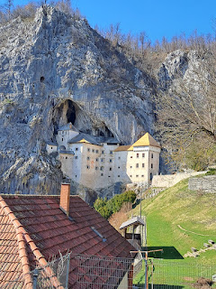

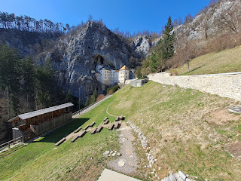

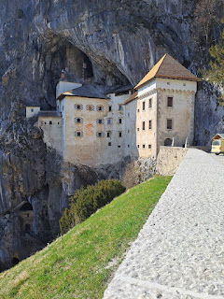

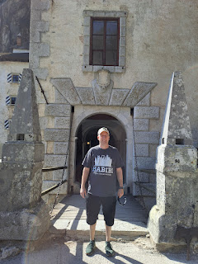

A young lady named Kristina was just inside to help us pay for tickets. She spoke excellent English and so I was full of questions. I asked her how to say "Hello" and how to say "thank you".

Hello, or Good Day = Dobradan

Thank you = Hvala

I asked if she would also be willing to let me video her saying something in Slovenian. She laughed shyly, but agreed to do it. She can be heard saying in her native tongue: "It's a beautiful day today. We're so glad you could come here."

Video of Kristina: (7 seconds)

https://photos.app.goo.gl/t122EhAsz2wDXQrR6

Some background on the history of the castle:

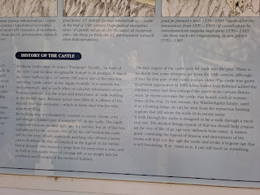

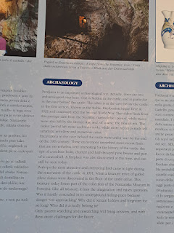

Erazem of Predjama was a pretty cool guy back in the Middle Ages. He was sort of a Robin Hood of that era.

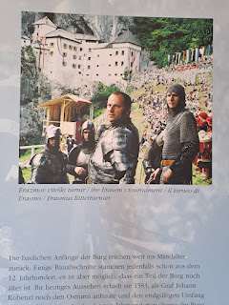

Here is a painting of Erazem that was on display in one of the rooms in the castle.

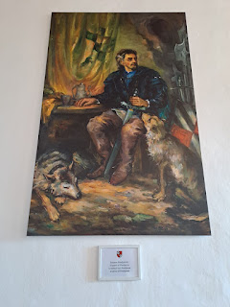

The view from one of the many castle windows.

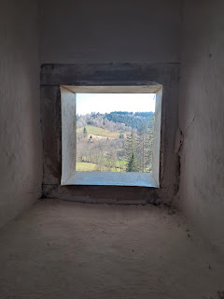

How about this Middle Ages toilet . . .

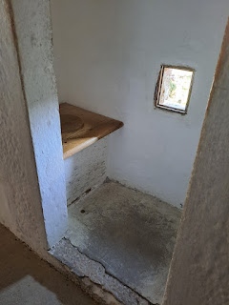

Next up: the torture chamber, because every castle needs to have one, right?

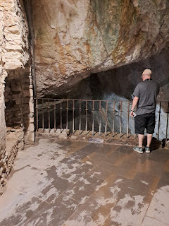

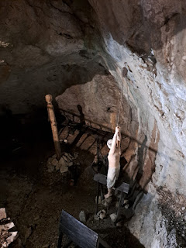

Hallway of antlers . . . and Scotty listening on his little device to an explanation of this room.

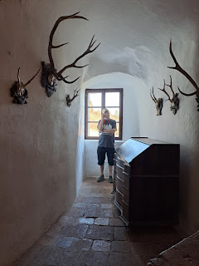

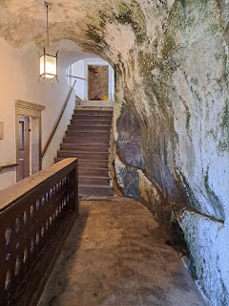

Some of these smaller stone balls are actually cannon balls!!

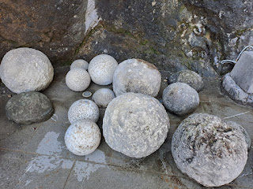

One of the steep stairwells going up. This time the steps were ORIGINAL, which meant that some of them were extremely deep and were more like a 2-foot height to get up to the next step.

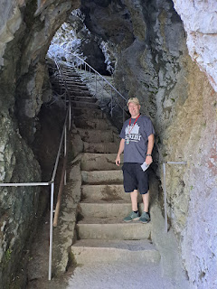

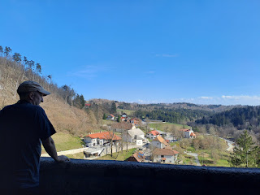

This was the only heated room in the entire castle. It was the main family's bedroom and living room space. The rest of the castle was pretty chilly, and I kind of regretted that I had left my jacket in the car.

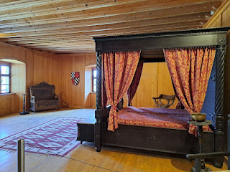

Through our listening device we learned that when it came time for church, the family could choose to stay in their heated room and participate through the windows that connected them to the chapel on the other side. Pretty cool! Or should I say, pretty warm . . . (dad joke)

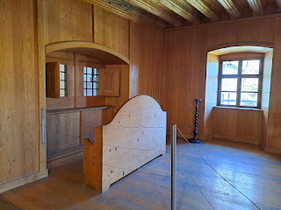

The window from the chapel side . . .

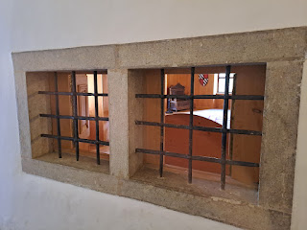

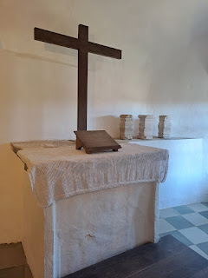

"Pieta" - Mary, holding her son, Jesus Christ, after His Crucifixion

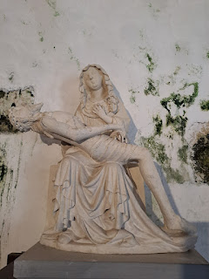

Interesting to see an ancient exposed wall in this room . . .

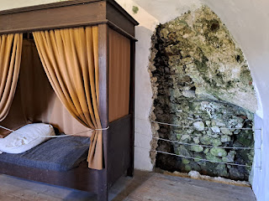

Next we went to the armory area of the castle.

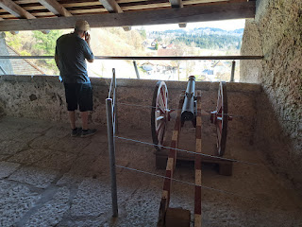

They stashed weapons, defensive armor, and even dishes and personal supplies in trunks.

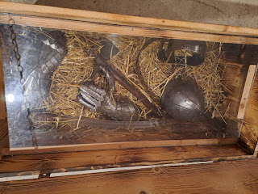

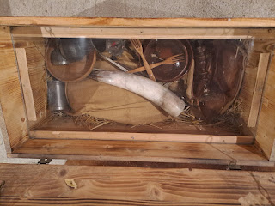

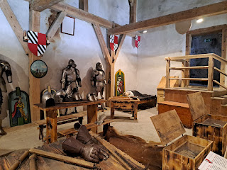

In one of the highest levels of the castle was this secret tunnel room that Erazem would use if he needed a quick getaway.

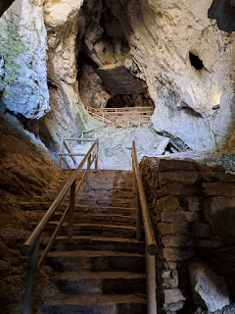

There was also a way to collect rain water up there. It would make its way "downstairs" where it was used as drinking water.

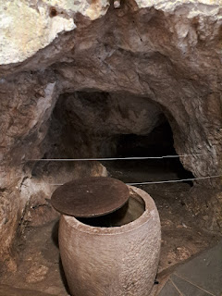

Video of the water collection: (12 seconds)

https://photos.app.goo.gl/TW4RgYTjjxmm7f2m7

Outside of the castle, and close to where we parked earlier, was this chapel. It was built in 1450 by Erazem.

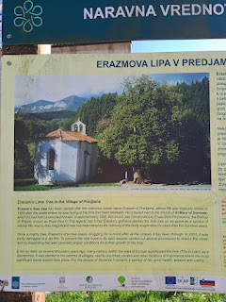

The explanation is in the photo just above this one, but it describes how when Erazem died, his wife planted a lime tree to honor him. It is still in place all these years later, even though it's been through a LOT.

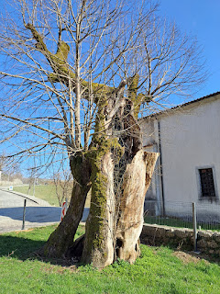

I'd love to come back and try some of the walking trails in the area. It's such a beautiful countryside!

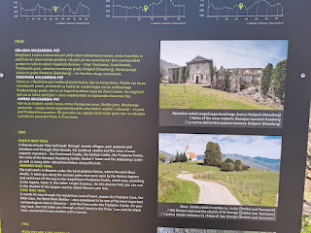

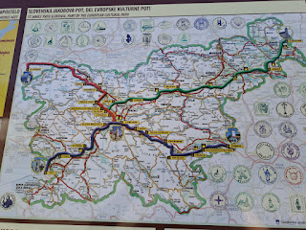

After an amazing tour, we began the last leg of our drive to Ljubliana. To see all of the photos and videos from Trieste and Predjama Castle, you are welcome to click on this link:

https://photos.app.goo.gl/8RQdPoUZpQ2gr83c9

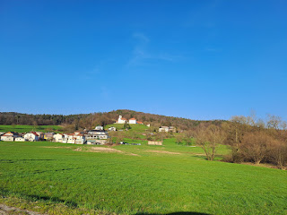

Once we got settled into our AirBnB, we went on a walk to find some dinner.

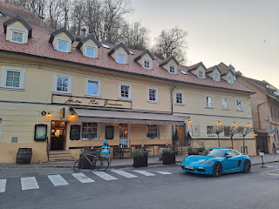

"Dragon Bridge" - -

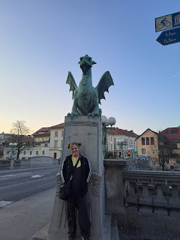

The Ljublianica River through the center of town . . .

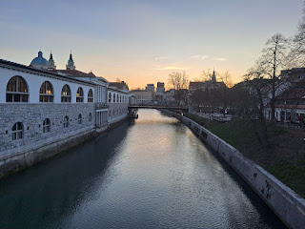

Some interesting art . . .

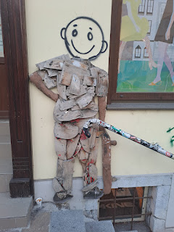

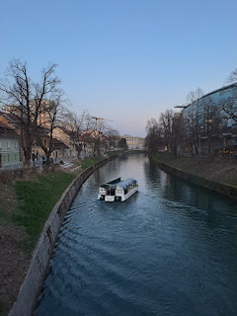

We brought our food back to the AirBnB, watched some America's Got Talent (All-Stars), and then went to bed.

Thursday:

We got up early so we could get right to it. We drove an hour north of Ljubliana to get to Bled Lake. This place was so gorgeous and magical, and it now ranks up there with my #1 place EVER (Switzerland).

The drive allowed us to also get a closer look at the Julian Alps, with their snow capped peaks.

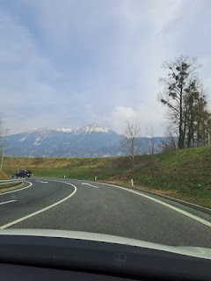

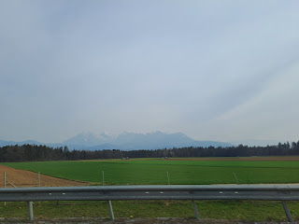

We parked close to the lake, in a paid parking lot. We chose the 4 hour option for 10 euros. Not bad.

I loved the ivy clinging to the buildings as we walked along.

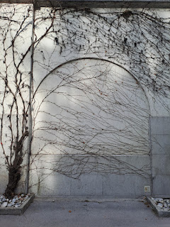

The parking attendant told us there is only one water closet (toilet) nearby, and pointed us in the right direction. This was one of those toilets where you have to pay 50 cents (euros) just to get in. There's a turnstile and video surveillance, so you can't just hop over or climb under it. Scott had to go in search of a place to get some change, so I waited outside the WC for him.

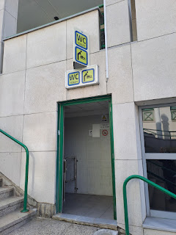

And then we finally got down to the water's edge. How magnificent!

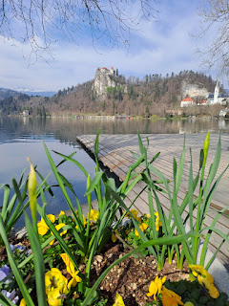

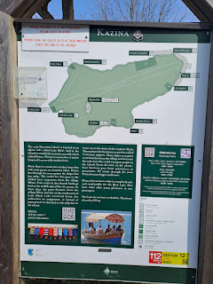

Video of some Olympic rowers practicing their time on the lake: (23 seconds)

https://photos.app.goo.gl/cyrKJmMtNPjsJhZz7

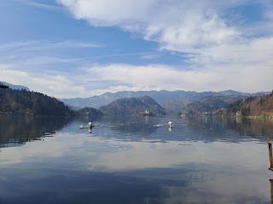

In the photo below you can see the next two things we visited: the church on the right, and then Bled Castle.

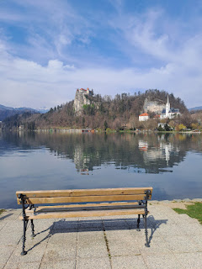

St. Martin's Church: The original wooden chapel was built before 1000 AD. The current chapel was built in 1905 but retains some of the walls that were built in the 15th century.

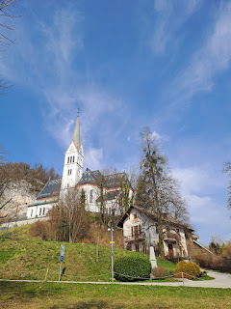

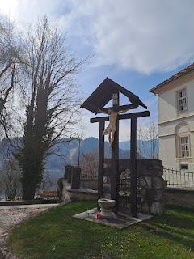

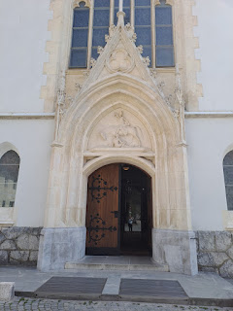

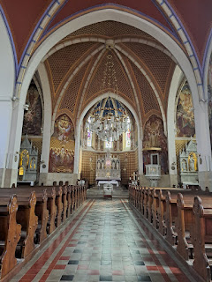

Next, we walked up, and up, and up some more to get to Bled Castle on top of the cliffs overlooking Bled Lake.

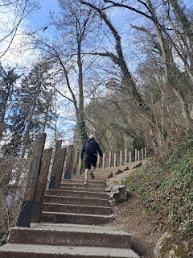

The existence of Bled Castle was first recorded in the year 1011 AD. Holy cow, that's more than a thousand years ago!!

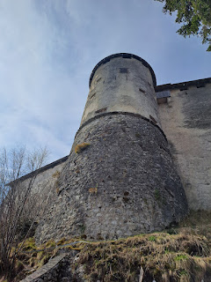

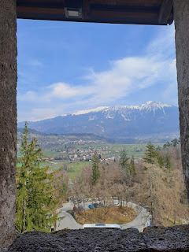

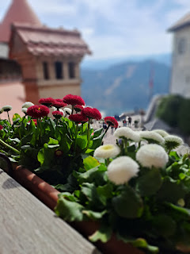

Castles often have these keyhole windows. From what we've gathered, it allows arrows, or other weaponry to be used through the bottom of the keyhole, while the narrow opening gives the shooter a good view without sacrificing the safety of their face and head.

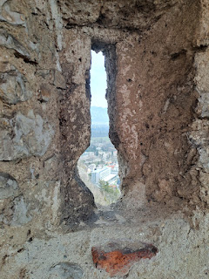

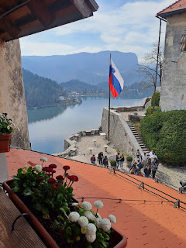

This guy, Arnold Rikli is so cool. Basically in the mid 1800's, he was on a quest to find a healthier way to live, both for himself and for the townspeople near Bled Lake. He read everything he could find and came up with a well-rounded plan for everyone.

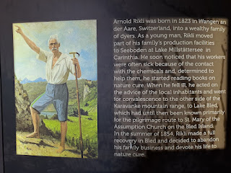

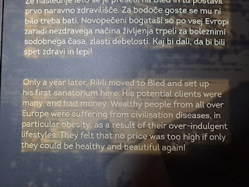

He organized some walking routes for both men and women, teaching that walking is good for your health. He also taught them that sunbathing was healthy, too. We know now that sunlight provides a good amount of Vitamin D, which helps your body in so many ways.

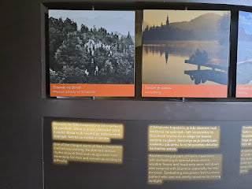

He also prescribed regular bathing, both in the lake and also in hot and cold baths.  In addition, he prescribed a vegeterian diet to avoid overindulging, which was very common back then. (and now)

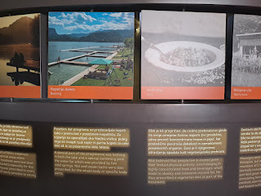

He taught that it was important to get regular massages to improve circulation and to walk barefoot if possible.

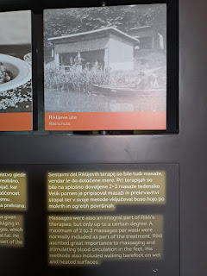

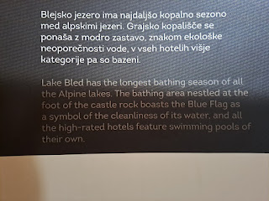

As time went on, another competitor began to build up his own similar business, which included more tourism. Arnold didn't like the crowds and the way things were changing, so he went back to Carinthia after helping the people of Bled for more than 50 years. He died not too long after.

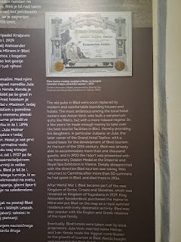

Two happy little lovebirds . . .

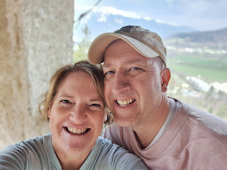

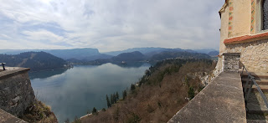

To see all the historical artifacts from Bled Castle and lots of other interesting stuff, click on this link to see the whole album:

https://photos.app.goo.gl/aEKPwb6aQWNLcUwY7

The trail around the lake is 6 km, about 3.5 miles. That's if you don't make any other stops or side trips, like to an old church or an ancient castle on top of a giant cliff . . . we probably did closer to 5 miles by the time we finished at Bled Lake.

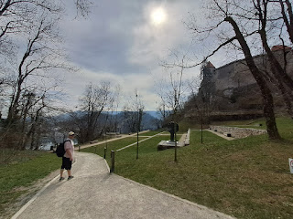

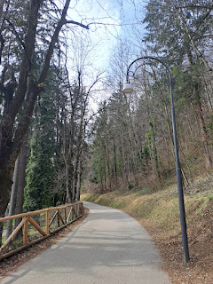

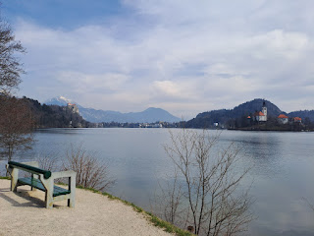

Pletna boats got their start back in the 12th century. They are made of wood and are 7 meters long by 2 meters wide. They are unique to Slovenia and Austria.

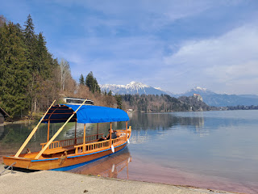

We wanted to go up to a special vantage point on top of a hill to see the lake from the opposite end where the castle is. We thought we chose the right path, but we didn't. We chose the Ojstrica Trail, but it didn't have the views that we thought it would. It ended up just adding to our "Buns of Steel" exercise regimen, where we do all the stairs we can muster in a day, followed by any additional steep inclines we happen to find. :) LOL

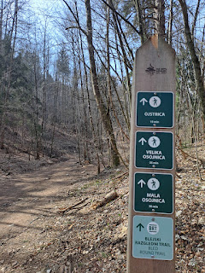

Scott channeled his inner mountain goat to crest this steep hill, adjacent to the main trail. He thought maybe he could get a better view of the lake from up there. He said he rated the view 3 out of 10.

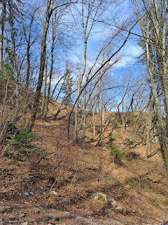

I was so happy to see him coming down through the trees after he had been gone out of sight for several  minutes . . .

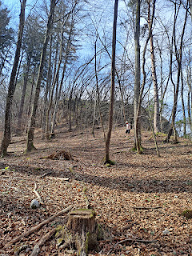

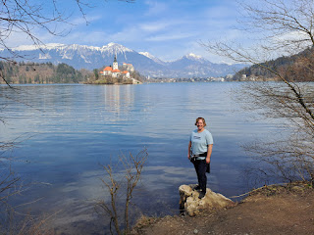

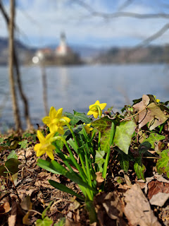

The restaurant I was so looking forward to for lunch, Cafe Belvedere, was closed for the season still, and wouldn't open until sometime in April. I was really disappointed, especially after all that hiking, because I was hungry and because the restaurant was highly recommended for their version of the famous Bled Cream Cake.

But we found an outdoor restaurant soon after, and it was part of a hotel on the lake. It turned out to be fabulous and I wasn't disappointed anymore about Cafe Belvedere.

This chicken caesar salad was the absolute best I've ever had in my life!!

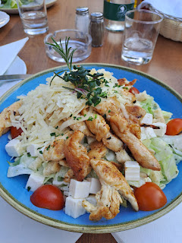

And the cream cake was absolutely dreamy. The cake had some tart dried cherries and some nuts. On either side was a small scoop of vanilla ice cream with LOTS of fresh whipped cream on top. Delicious!!

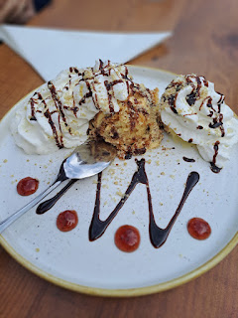

Once we filled our (tummy) tanks, we drove a few minutes north to see Vintgar Gorge. We drove through a tiny little village outside of Bled where the houses were charming and allowed us to see the style of homes in the area.

Video of the village homes: (28 seconds)

https://photos.app.goo.gl/AuxA5NEQZCJ9hy3F8

This next sign shows how Vintgar Gorge came to be . . .

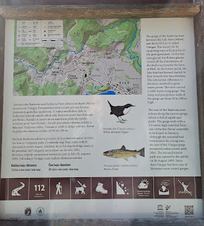

Sadly, however, the trail was only open for about 1/8 mile. Where it crosses the river, it had a blocked door so you couldn't continue on to the other side. It is due to fully open in a few weeks . . . darn it. Well, we will just have to come back again! Perhaps in the fall with Amber and her family . . .

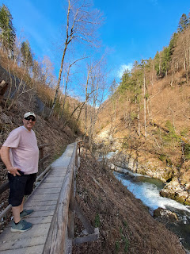

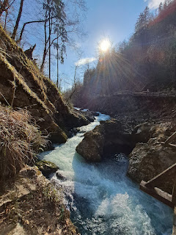

Video of the river rushing along: (23 seconds)

https://photos.app.goo.gl/4QzuF8AVBZL9CaBfA

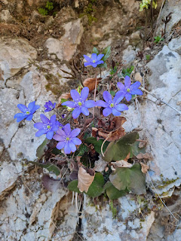

We walked back to the car and drove to our AirBnB in Ljubliana. After a little rest, we put on our walking shoes one more time to go out in search of food. It was a mile each way to the restaurant we chose. So that makes about 7+ miles we walked in one day.

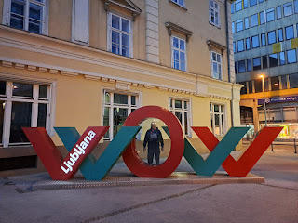

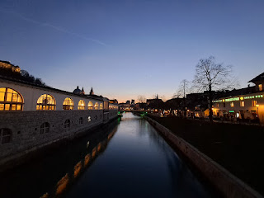

At night, we saw that there was a lighted path going up to the Ljubliana Castle. As we stood there talking about it, we saw a funicular going up to the top! Super fun.

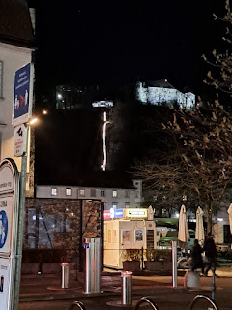

Friday:

We slept in and slowed down a little, which was nice. Our only goals for the day were to tour the Ljubliana Castle and to visit the Open Kitchen downtown to try some different foods.

Both are in the same vicinity, and both are about a 15 minute walk from our AirBnB. The main river next to the Central Market has a bridge where everyone hangs their locks as a symbol of their love for someone.

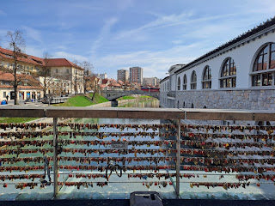

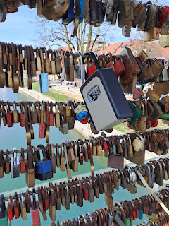

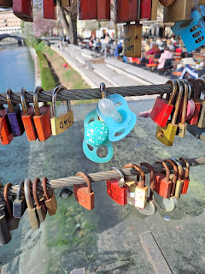

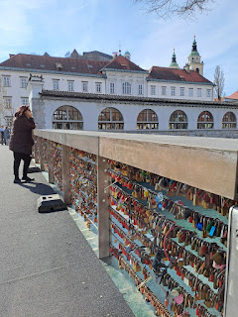

We slowly walked through all the farmers market booths, with their shoes, purses, bags, clothes, crafts, fruits, vegetables, and beautiful flowers. School children were also on a walking tour with their teachers, and what a delightful thing to do on a Friday morning!

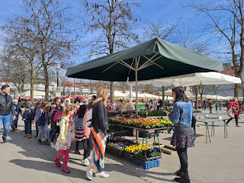

The path to go up to the Castle was across the street from the Farmers Market. Uphill once again, ha ha. I always say, "Buns of steel don't just make themselves . . ." My only goal, as I took small but steady steps up the steep hill (along with my heavy breathing), was to stay in front of an older lady and to not let her beat me. She was about 30 paces behind me, and looked to be maybe in her upper 60's or early 70's. She had a steady pace as well, so I knew I couldn't stop even once to catch my breath. Nice and easy, small and steady steps . . .

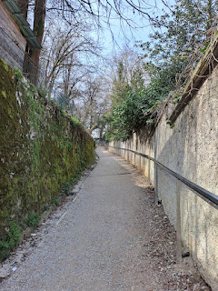

I did it! I made it, and I beat her. Ha ha. She had no idea I was so competitive, or maybe she would have tried harder. :)

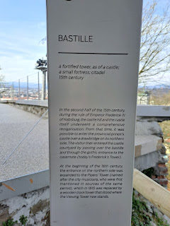

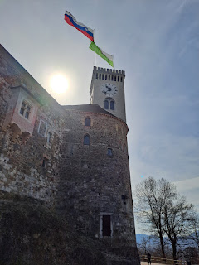

When life and love, catastrophes and triumphs have taken place so long ago, and you have a chance to touch something like an old wall where those things happened, you do it.

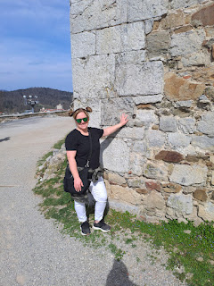

Scott tried his hand at doing a (posed) action shot as we went across the drawbridge . . .

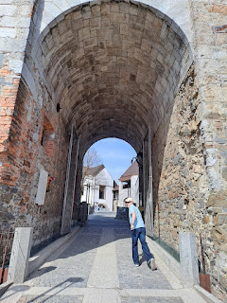

In the upper courtyard, there was a model of the layout of the castle.

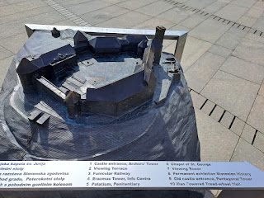

I'm not sure what kind of tree this was, but I was in love with it! Maybe a magnolia?

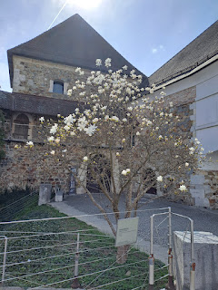

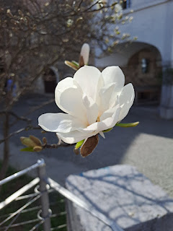

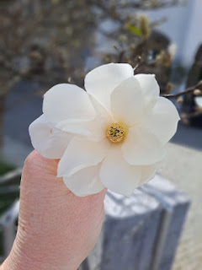

Ljubliana Castle is a very touristy castle, with shops and cafes everywhere. Yes, there is history to discover here and there, but the marketing stuff was a little distracting.

However, I loved the suit of armor.

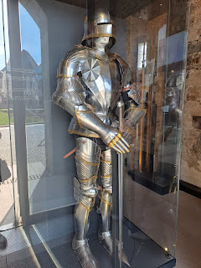

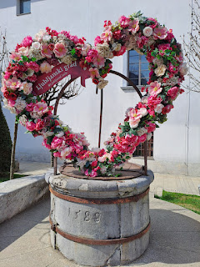

The penitentiary was interesting, but kinda eery at the same time.

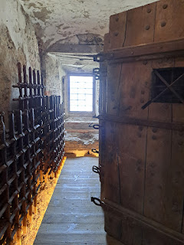

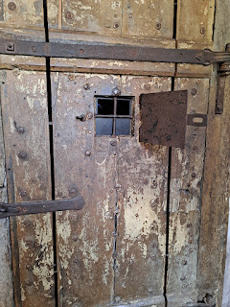

When you read that these buttons are called "bone buttons" . . . you tend to wonder where those bones originated from . . .

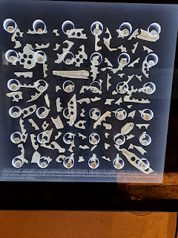

As I am starting to get a feel for some castle layouts, I'm always puzzled that the jail, or the torture chamber, is typically next to the chapel and/or the quarters where the priest lives. Is it because he is needed when the accused wants to repent? Is it because of the supposed symbolism of evil vs. good? Is it because the priest is looked to as the "one" who prays for a damned or tortured soul, and he would be the one in the castle to hear the agonized cries? Yuck. I feel for him in those circumstances. I wouldn't want to be right next door to any of what goes on in those cells or chambers.

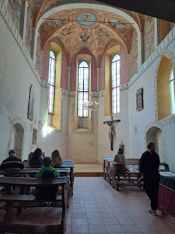

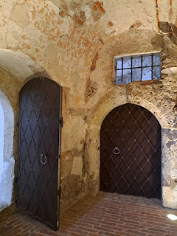

On a lighter note, puppetry is an important part of Slovenia and the Ljubliana Castle has a dedicated Puppetry Museum, described on the internet as being one of the best in the world. While puppetry has been around for centuries, even as far back as the 5th century BC in Ancient Greece, it was only "recently" introduced into Slovenia by a painter in 1910 (Milan Klemencic). He brought his knowledge of puppetry from Italy and Germany and partnered it with his art expertise.

I thought the Puppetry Museum at the castle was very well done. It had a mixture of hands-on experiences, carefully selected displays, and informative fun facts.

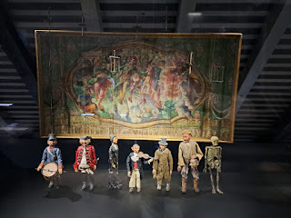

Even during WWII, puppetry continued to play an important role in entertainment and storytelling.

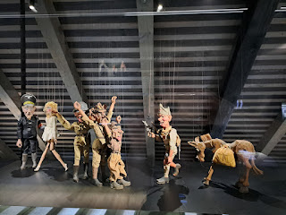

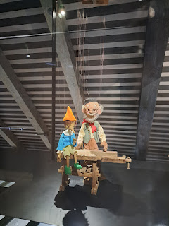

I loved the artistry and beauty of this girl and her dolphin . . .

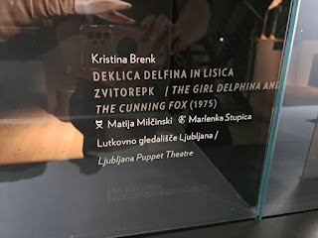

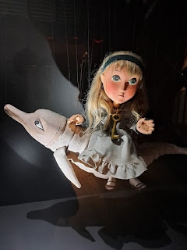

We sat down to rest for a few minutes as we selected a short puppet film to watch, entitled "Little George". It seems to be basically the same storyline as the original play, entitled "George and the Three Rascals". I recorded pieces of the film, which lasted about 6 minutes total.

Video #1: Little George (1 minute, 56 seconds)

https://photos.app.goo.gl/iyCx1nNs33A8dMC5A

Video #2: Little George (1 minute, 38 seconds)

https://photos.app.goo.gl/1HZH76bhMbGmQMbt8

Video #3: Little George (51 seconds)

https://photos.app.goo.gl/4pfvVHpyod9bAhNy9

Video #4: Little George (last 5 seconds) LOL

https://photos.app.goo.gl/6EBcZXctwhsDzXTE6

I gained an appreciation for how vivid and entertaining puppetry can be! They used it to tell happy stories, sad stories, nail-biters, war happenings, love stories, and to teach a moral lesson (or two) to the children.

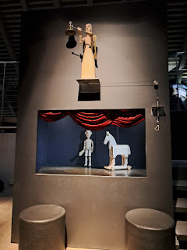

Scott and I also had a chance to take turns practicing our puppetry skills, while the other one was an enthusiastic audience member. :)

Video of Scott's mini puppet show: (15 seconds)

https://photos.app.goo.gl/3KjThusiTS9JG9K56

Next, we headed up to the top of the viewing tower for a 360 degree view of Ljubliana.

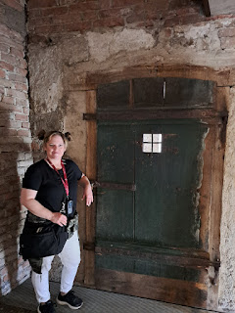

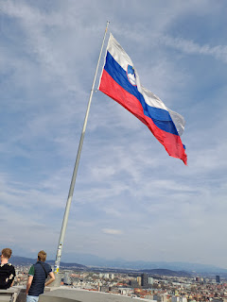

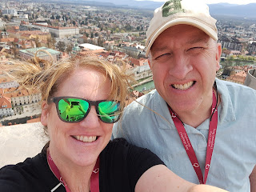

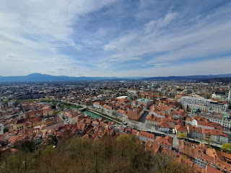

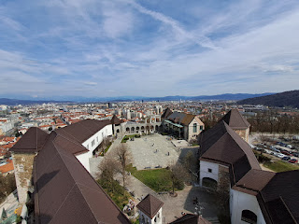

Video of the 360 view on top: (53 seconds)

https://photos.app.goo.gl/fYT5jniwg1Qu87Et6

The last area we visited in the castle was an artifact sort of room. Scott's legs were tired by this point so he found a place to sit while I did some more looking.

The oldest wooden wheel with an axle in the world was found in Ljubliana. It is believed to be as old as 3200 BC. While this is a replica, the original is in the City Museum of Ljubliana.

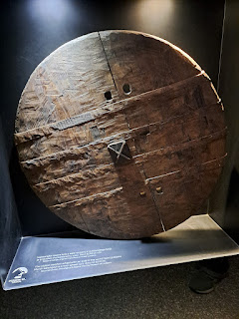

The Bible was translated into Slovenian in 1584, and was transported by barrels to Slovenia.

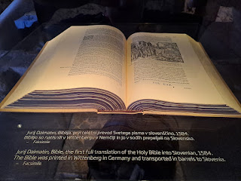

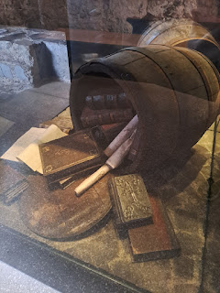

A display of Slovenian currency before the euro was accepted all throughout Europe.

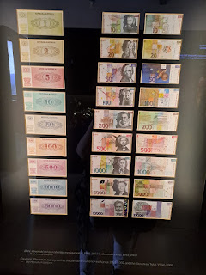

It was about this point that I started "checking out" because of overstimulation. This portion of the castle with all the Slovenian history was turning into nothing but nonstop noise to me. As I walked down each aisle of displays, there were multiple audio presentations all happening at the same time, overlapping with each other and sending my ADHD into orbit.  And we were the only ones in the room!! If I were in charge of designing the audio presentations, I would make each one touch sensitive. If no one touches the screen, then that screen stays quiet. Only the screens being viewed by a patron would be the ones talking.

We decided it was time to leave and get out into some fresh air to clear our heads.

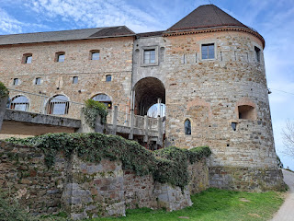

We headed down the trail from the castle and into the center of Ljubliana, with the intent to find some food at the Open Kitchen.

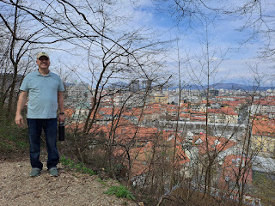

This sign means Open Kitchen, essentially 50+ food booths for you to sample different cuisines and ethnic foods all in one place. The chefs are preparing the food right in front of you, which makes it so interesting and fun to watch what they do.

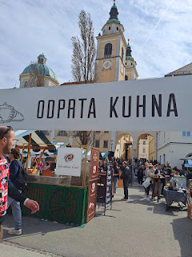

Video #1: Pitmaster chef working his magic on the grill. (20 seconds)

https://photos.app.goo.gl/CkfDKHecQrCuM9kK6

Video #2: Shawarma expert, shaving meat from the rotisserie. (20 seconds)

https://photos.app.goo.gl/P1insPoB95rtX9f89

There were booths with Asian cuisines, such as sushi, poke bowls, fried octopus or squid, etc.

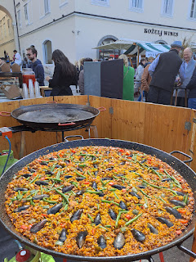

After we wandered past all of the booths to see what our options were, I decided to get some Slovenian food for my Round One. I chose the fried chicken and potatoes.

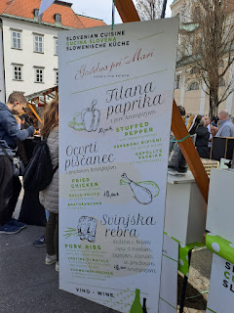

It was amazing! Even the potatoes were perfection. I think the batter for the chicken was either cornmeal or polenta. We shared this plate and ate every single bite.

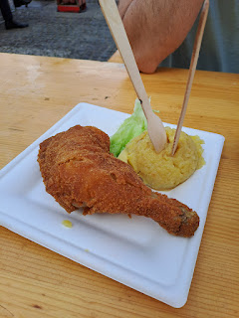

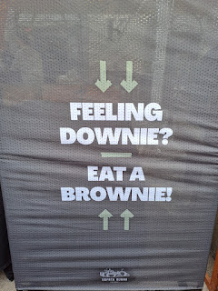

Scott chose this next entree for our shared Round Two. I took one bite of the chicken and thought it was pretty bland, especially after the other chicken that we just ate. And I didn't want to fill up on unwanted food because I saw plenty of desserts that I was interested in, ha ha. So I let Scott eat the rest of the bowl.

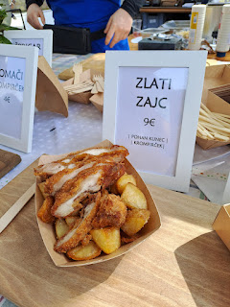

Round Three: I'm not sure what ethnicity this food was, but it was DELICIOUS!! I chose the Wild Ranchero.

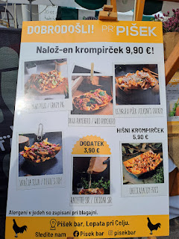

Melt in your mouth shredded beef on top of seasoned fries, with pickled onions and some other unidentifiable stuff, ha ha.

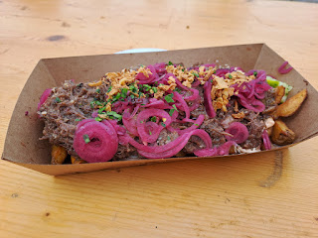

Some of the desserts were fancy, like these . . .

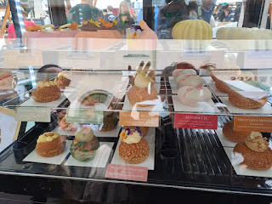

There were macaroons, scones, cheesecakes, chocolates, cakes, brownies, etc.

But I wanted THIS: KAISERSCHMARRN

Video #1: The chef is pouring the batter into the heated woks. (21 seconds)

https://photos.app.goo.gl/hyoXLWjWMNrE1Evp8

It cooks into a thick crepe or pancake. And then he chops it all up with a pizza slicer.

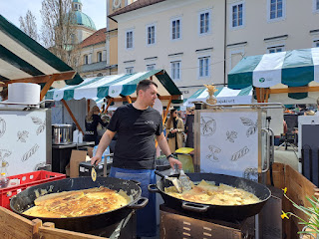

Video #2: Slicing it all up. (25 seconds)

https://photos.app.goo.gl/AetXxVisRr6VfzdT7

Then he added some sugar in the middle.

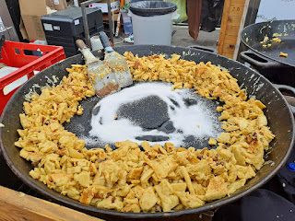

Video #3: Then he let the sugar caramelize. (11 seconds)

https://photos.app.goo.gl/w7jm8J49Hi5Ls1zZ9

Then it's ready for serving. You can choose between getting a lovely creamy chocolate sauce drizzled on top, or a tart strawberry sauce, or a mixture of both. I chose to get both. This was an EPIC DESSERT. If I weren't so full from eating chicken and then shredded beef, I would have eaten every single bite of this. I ate about 90% of it and was definitely in dessert heaven . . .

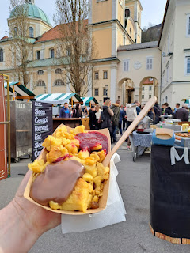

Video #4: Here is a video from when we were eating Round Two, showing the scene and the vibe of the Open Kitchen. (17 seconds)

https://photos.app.goo.gl/DuAaKkhWmqmQnqVGA

What a fun event that we were able to take part in! We were full to the brim, but also happy that we could take part in this cultural event while we were in town. This is the 11th year of Open Kitchen.

We walked back through the flower market row of the Farmer's Market. I really wanted to get some ranunculus flowers, because those are my favorite!! But ultimately I talked myself out of it, because the following day we would be picking Avery up with all of her belongings. I didn't want the plant to get squished with the car being so full . . .

So I just admired . . .

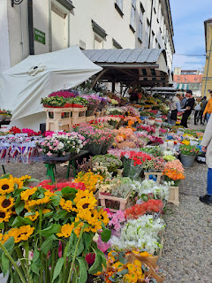

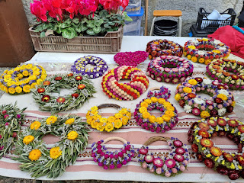

We also saw an EGG VENDING MACHINE. That was a first!

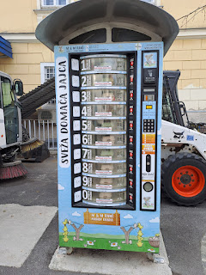

In Europe, all of the colorful egg varieties are shelf stable, so something like a vending machine would be just fine. But in the U.S., our eggs are washed and sterilized to the point that they HAVE to be refrigerated (if bought in a store). Interesting to note the differences in their continent vs. ours . . .

Saturday:

We got up and ready, packed up and checked out by 8:45 a.m. We drove in a westerly direction to go to the Skocjan Caves before leaving Slovenia. It was a rainy morning but that doesn't ruin a cave tour!

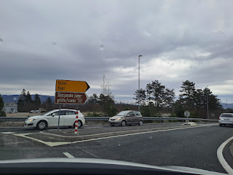

Skocjan Caves became a UNESCO protected site in 1986 (I believe it was).

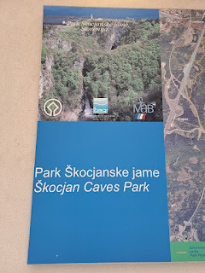

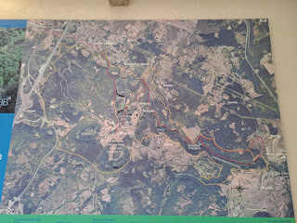

Our tickets were $16 each. When our group headed out, we went on a short walk to get to the starting point.

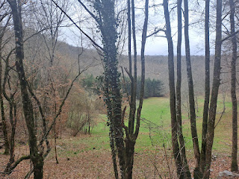

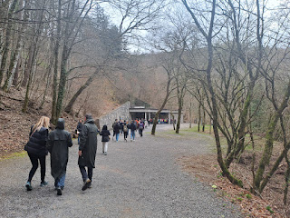

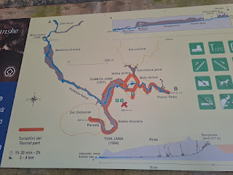

They broke us up into 3 groups: A Slovenian language tour, an English language tour, and a Hungarian language tour. We, of course, chose the English group.

I took a video of Natasha, our guide, as she gave instructions: (2 minutes, 1 second)

https://photos.app.goo.gl/YzqPgPU7JiKEiXBZ6

She is a no-nonsense kind of person, ha ha. I was sad that we couldn't take any photos in the cave, but when we finished and were at the "exit", then we were able to take a few photos. You'll have to Google the Skocjan Caves for images because it was truly astounding. We crossed the footbridge that you'll see in those images, which was FAR above the rushing Reka River below.

Natasha pointed out to us during the tour that the ENTIRE middle cave - where the footbridge is - filled up with water from the Reka River in 1965. Basically what happened was a LOT of rain came down, which caused some flooding, which then picked up a lot of debris as it pushed its way along. The debris went into the cave and became like a "plug", causing the water to fill up the massive cavern because it had no way to drain itself out. Scott said to me, "So like a giant toilet clog??"

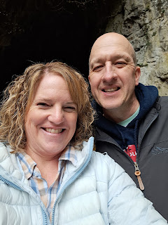

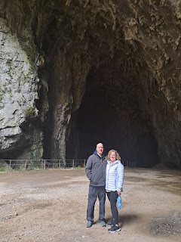

As we exited the cave, we had a short hike to get to the funicular that took us back up to the starting point.

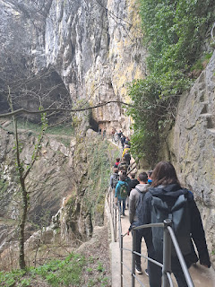

Rika River cascading toward the cave

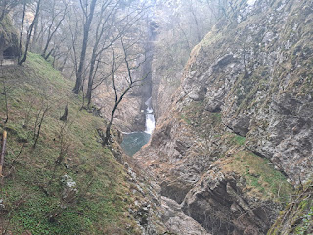

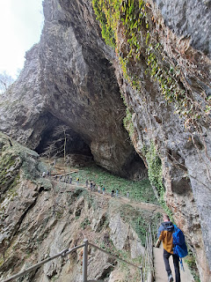

The large hole in the center of this next photo was where we came out of.

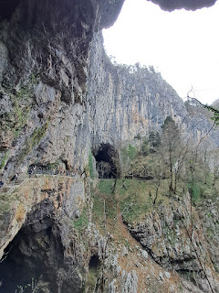

We rode in the funicular up to the ticket office area and the parking lot, and then off we went towards Aviano to see Benson and Avery. :)

Just prior to passing through the border crossing of Slovenia back into Italy, we were flagged by the Slovenian police to pull off to the left side. A police officer came over to ask for Scott's passport, license, and car registration. He didn't need my passport, just the driver's. It was pouring rain, so the officer walked back to get in his van behind us and do a background check.

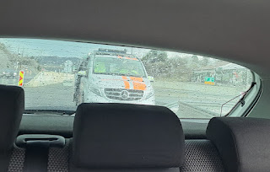

Eventually he came back to retrieve Scott and ask him to get in the van, too. It was apparent that something was wrong, but we didn't know what it was yet. After several minutes, Scott came back with a paper that explained it all.

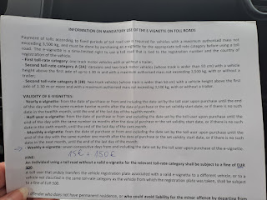

The officer said that we failed to pay the fee in advance to drive on their roads while we were in their country. We did not realize that this was a "thing". A camera must have recorded our license plate number, which then showed that we hadn't paid the fee. He also said that they have made it a point to educate the U.S. service members in Aviano, since they come over pretty often to Slovenia. Scott replied by saying that we are not from Aviano, but we live in Vicenza . . . the officer responded with something like an "ohhh, i see . . ."

I'm sure we're not the first ones to have to learn this the hard way, but we're definitely going to spread the word among our friends here in Vicenza! If we had done the 7-day fee in advance it would have only cost 15 euros. But now it cost the 15 euros PLUS another 150 euros. Ouch.

We were sidelined for about 20 minutes total, and then finally we were free to go. At least they were nice.

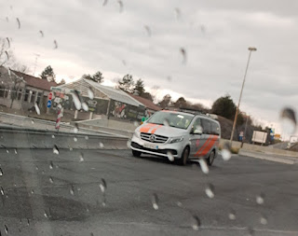

When we got to Benson's house, I gave him a really long hug. Then I paused and said, "Do you realize that this is the first time I've been able to hug you since you almost died back in January?" He agreed, and then I hugged him again for a good long while.

We visited for a bit while Avery was still sleeping. It was nice to spend a little time with Benson and see how he was doing. He now has a target date (finally) for when he will move to Korea. It looks like April 30 is when it will all go down, although it is subject to change. I was so sad to hear that date because I was so hoping that Jacob, Hannah, and Jack could see him before he leaves. They all fly in on APRIL 30th!!! Unless a small miracle happens, they will just miss each other . . .

When Avery woke up, it was like we were back to square one with her. She was extremely shy and didn't want us to hold her at all.

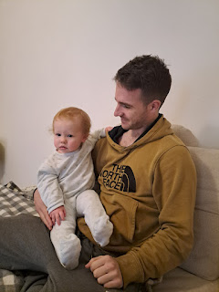

She seemed very comfortable with Benson though, which was nice to see. He doesn't see her much these days.

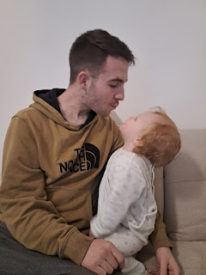

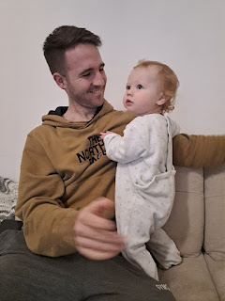

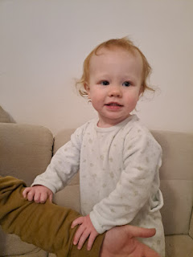

We took Benson out to lunch at a local Filipino restaurant. We didn't know what to order, and the chicken with fried rice looked really good, so all 3 of us ordered the exact same thing, ha ha. Later, Jacob gave us some pointers on what we COULD have ordered, based on the photo that Benson had taken of the menu.

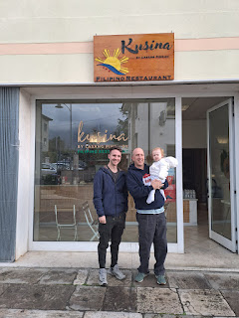

Avery loved the fried rice, just as we expected that she would. Once we finished, we loaded up Avery's things and drove back home to Vicenza.

Scott and Avery outside Benson's house - as we came back with the food . . .

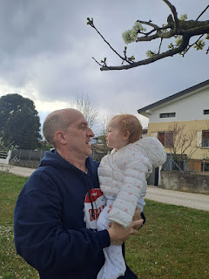

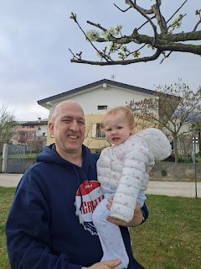

The clouds were quite magnificent as we drove south. Slovenia had rain to the east, but Northern Italy was just cloudy and dry.

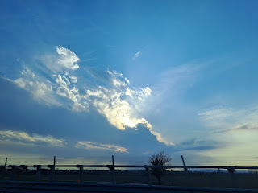

Avery and I got reacquainted in the back seat of the car. At one point, I got overwhelmed with love for her and I started crying. What a sweet girl. I just love her so much and I feel so grateful for each time I get to spend with her.

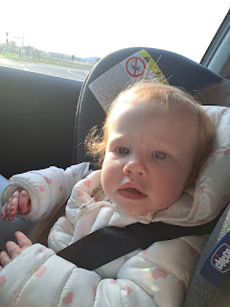

Avery is always great in the car. She loves to look around and notice her surroundings, and each time we stop somewhere, such as a toll booth, she takes note that we have stopped and is very interested in what might be going on.

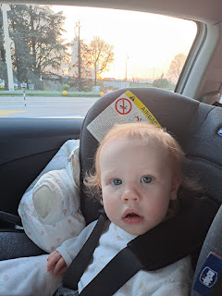

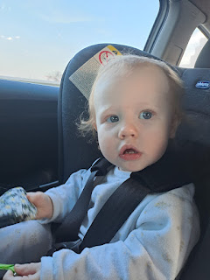

We got home to Vicenza just as the sun was going down.

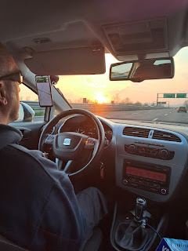

Scott is so great. He's great in lots of ways, but one of those ways was how he let me just play with Avery when we got home while he unloaded EVERYTHING from the car. Not only did he carry Avery's pack & play and all her bags of stuff up the stairs, but also our suitcases and everything from our 4 day trip to Slovenia. XOXO

Video of Avery playing with a new toy we just bought, while Scott carried in the last load of stuff from the car: (48 seconds)

https://photos.app.goo.gl/P72SoHq5my7MZRvP9

Sunday:

Avery slept really well during the night. She only cried out once, but then went right back to sleep. She was hungry and ready to eat some pancakes and eggs for breakfast.  I always try to take lots of pictures to send to Kylie so that she knows how Avery is doing throughout each day. Kylie appreciates this very much! :) (Kylie is having a weekend getaway with some friends in Greece.)

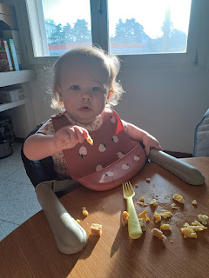

As we were getting ready for church, Scott was worried that we didn't have any socks or shoes for Avery. I told him that Kylie said Avery didn't like socks or shoes. Scott thought it would be a good idea to test that theory, ha ha. He took a pair of his long white socks and placed them on Avery, pulling them all the way up to the top of her thighs. She didn't seem to mind, so Scott chalked that up as a success.

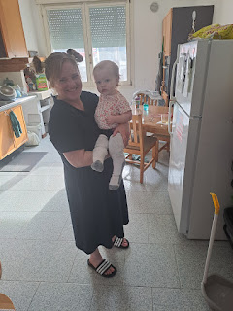

That's not how we dressed her for church though . . .

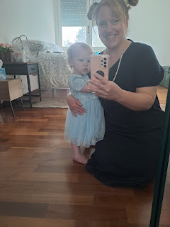

I bought this cute Easter dress for her ahead of time from the Target in Idaho Falls.

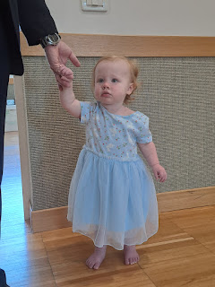

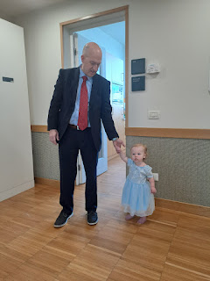

She did so amazing at church this time! She made it through the whole 2 hours and was happy the whole time. It was even more remarkable because our church is from 11:00 - 1:00 AND we just sprung forward during the night to daylight savings here in Italy, so that means we lost an hour . . . She was a champ, though.

Here she is on the drive home from church, starting to get a little bit sleepy . . .

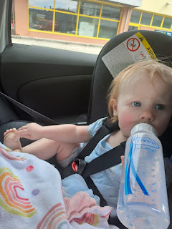

Scott and I tag teamed with the prep for dinner, taking turns with who tended to Avery and who did the chopping or stirring, etc. I love how snuggly and relaxed she is when we look out the kitchen window and watch all the cars going through the roundabout.

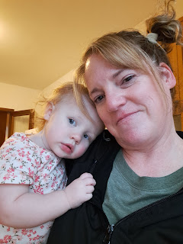

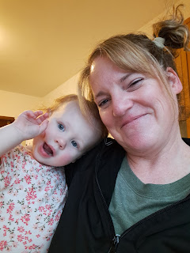

She snarfed up her dinner tonight, too. What a good little eater!

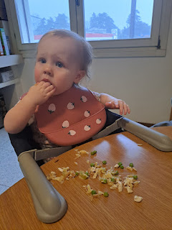

I made Lemon Chicken Orzo Soup. (I should say WE made the soup . . .) I skimmed out the chunky parts of the soup for Avery, and then I made her some pasta with shredded cheese on top to fill in her meal a little more. She ate and ate and ate!

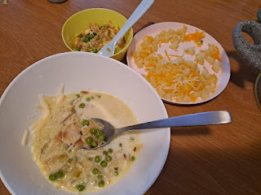

Bathtime and then bedtime for Bonzo . . .

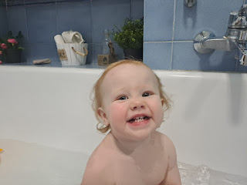

What a great first week in Italy!!